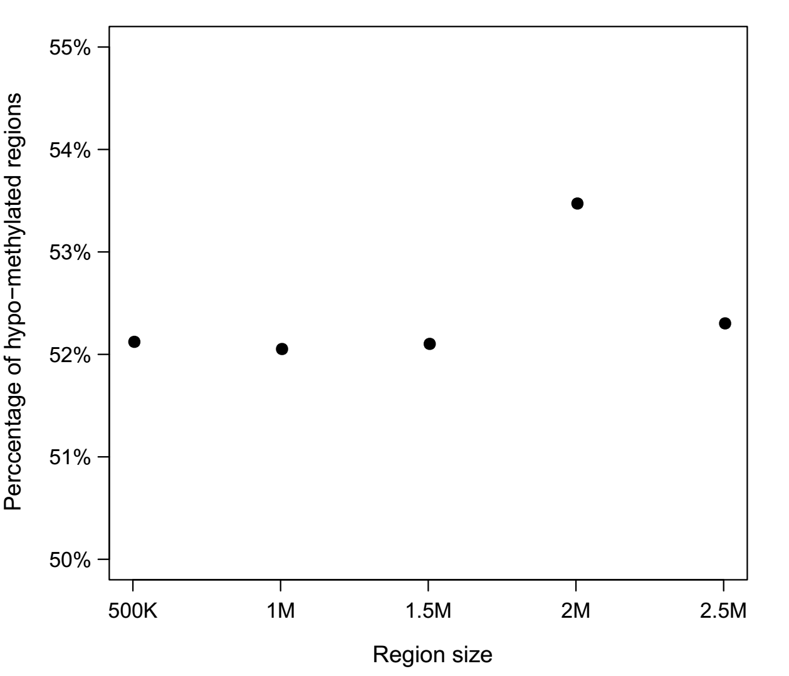

**Fig. S1. Percentage of hypo-methylated regions at 500-Kb, 1-Mb, 1.5-Mb, 2-Mb and 2.5-Mb size of P3 across the genome.**

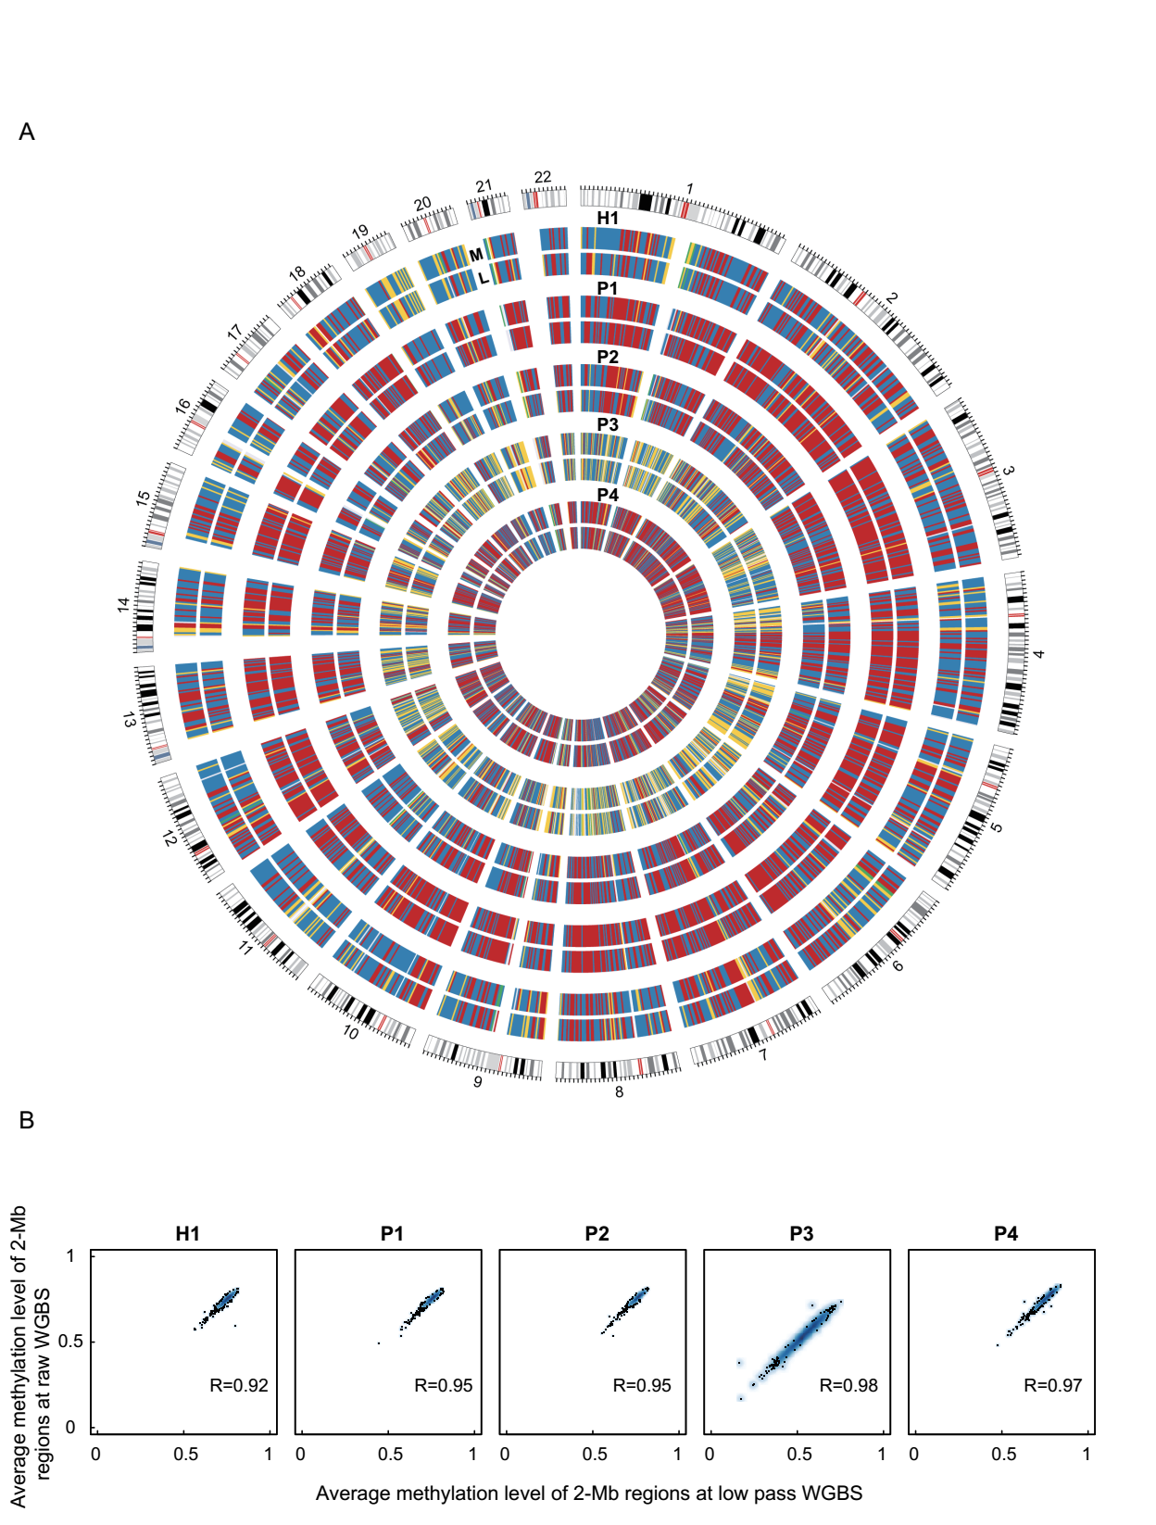

**Fig. S2. Comparison of 2-Mb methylation level between 5M re-sampling low WGBS and total WGBS of cell free DNA from 5 individuals.** (A) Genome-wide DNA methylation level of 2-Mb regions for each comparison are shown in circos. The data represent the average methylation levels for 2-Mb regions. “M” represents the total WGBS and “L” represents the 5M re-sampling WGBS from medium WGBS. Colors represent (from green, purple, yellow, blue and red) the methylation level from low to high. (B) Comparison of average DNA methylation level of 2-Mb regions between randomly sampling low and total sequencing reads. The Pearson’s correlation coefficient is large than 0.92 in all the 5 samples.

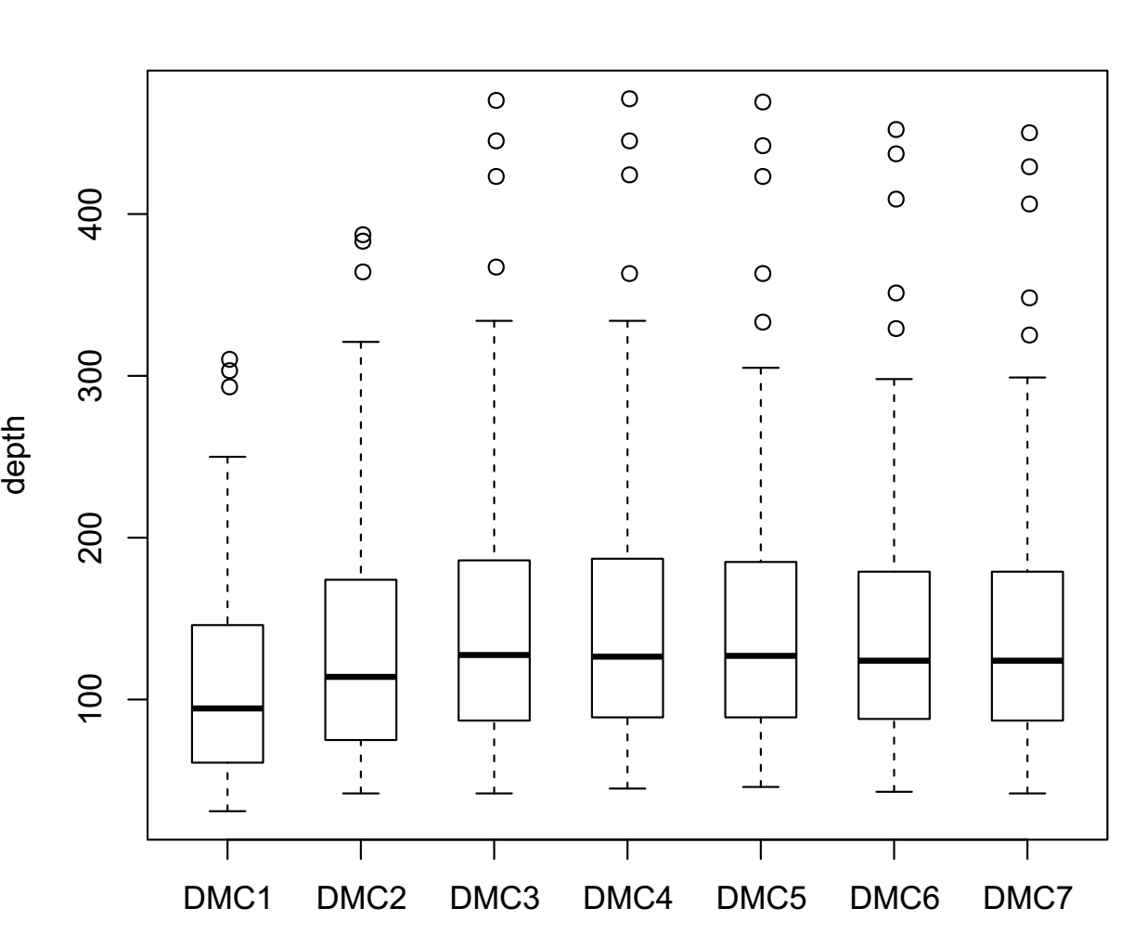

**Fig. S3. The depth of 7 DMCs of SENP5 in all the samples.**

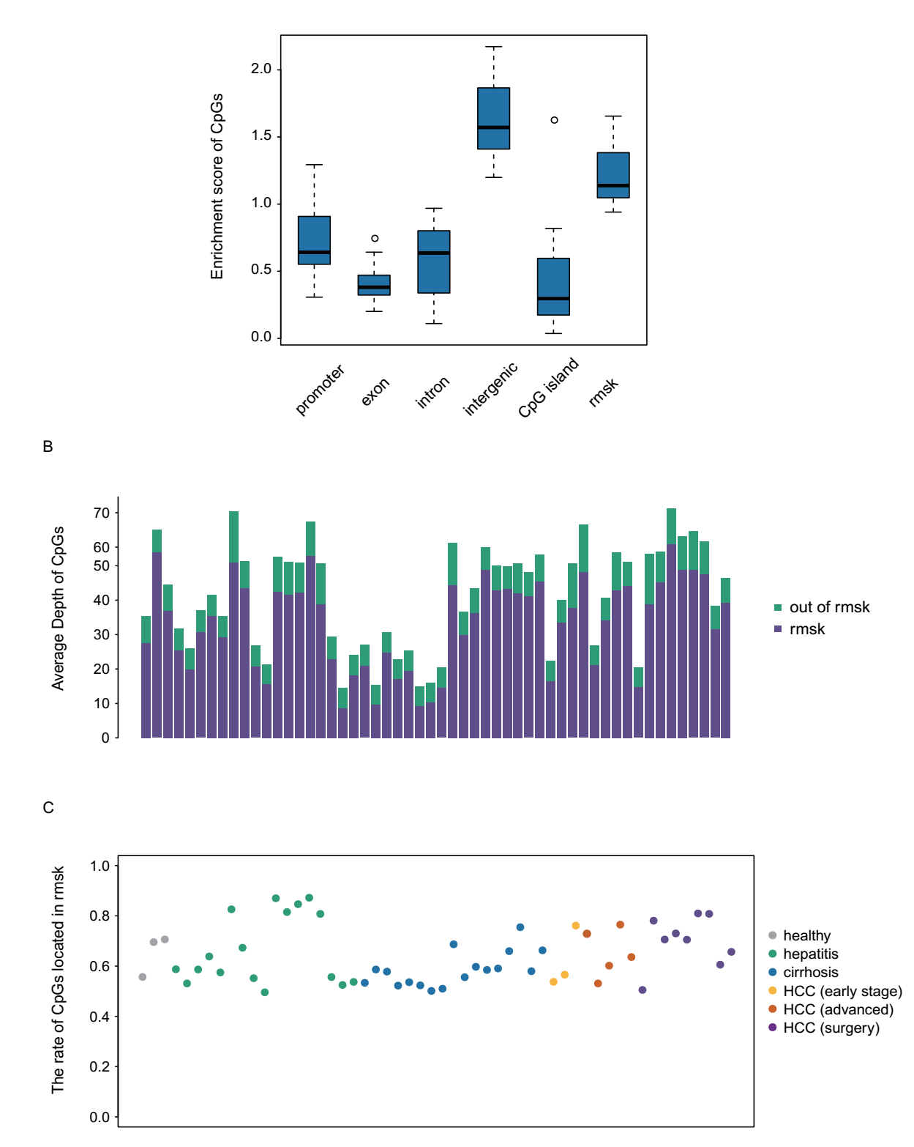

**Fig. S4. The genome feature distribution of CpGs at the low-pass WGBS.** (A) The enrichment scores of CpGs in promoter, exon, intron intergenic, CpG island and repeat regions of all the samples. (B) The depth of CpGs located in repeat regions and CpGs located outside of repeat regions. (C) The percentage of CpGs located in repeat regions in all the individuals.

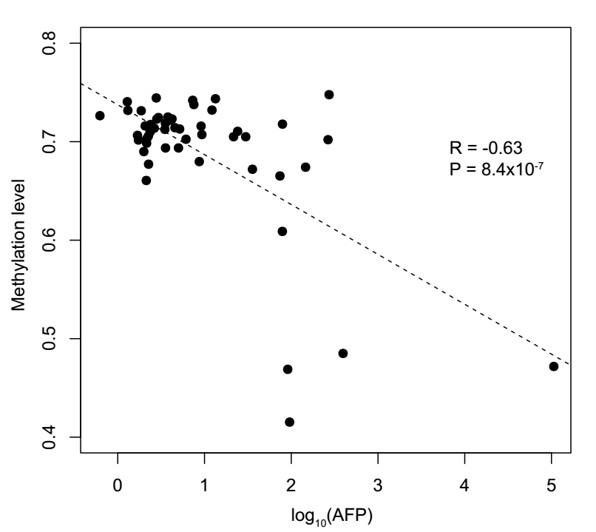

**Fig. S5. The correlation between AFP (log10) and average methylation level of the CpGs within the 100bp of the reported HBV integration sites (MethylHBV).** 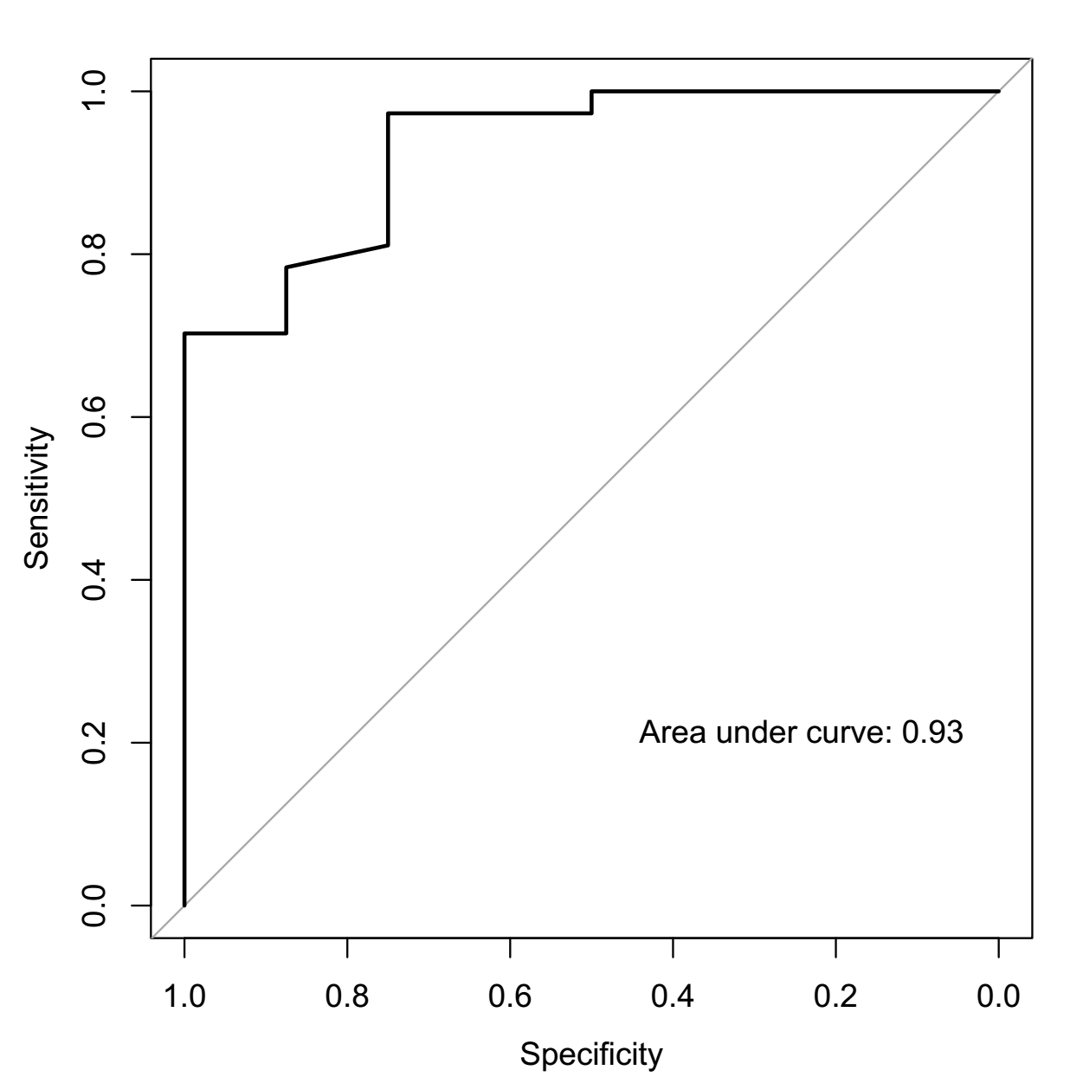

**Fig. S6. Receiver operating characteristics (ROC) curve for HCC patient detection by MethylHBV in discriminating HCC from individuals without HCC.** The area under the ROC curves (AUC) was 0.93